# Network Modelling

represented by a set of nodes, a set of arcs(edges), and functions

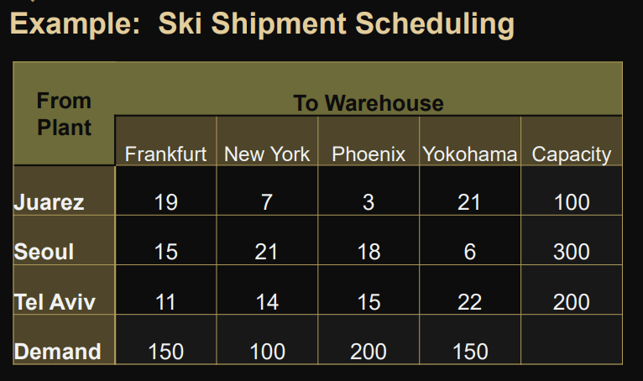

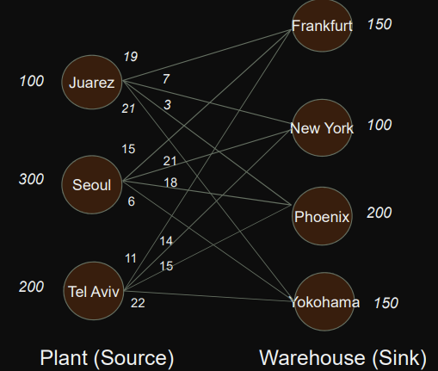

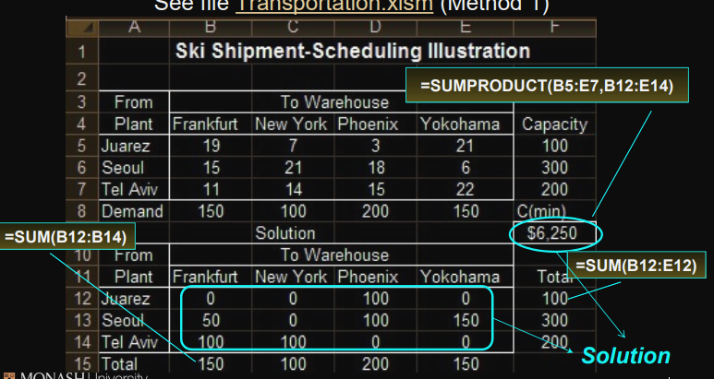

## Method:

### Northwest Corner Method

Easy for calculating manually

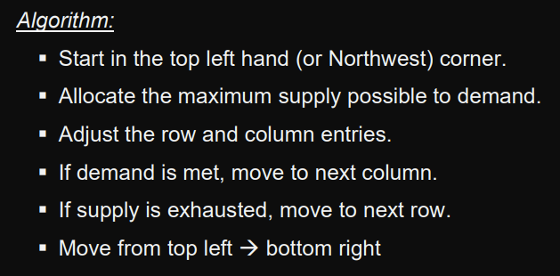 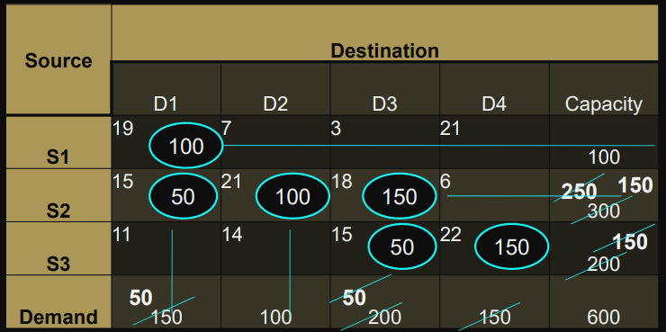 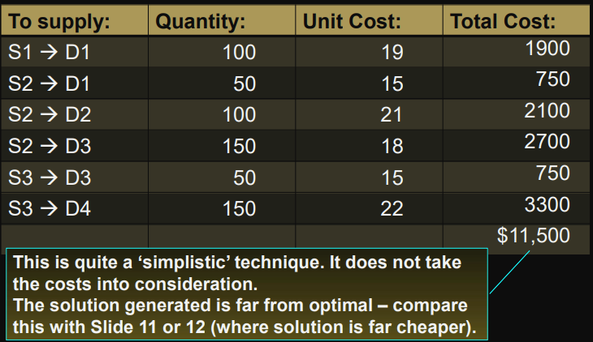

### Vogel’s Approximation Method (VAM)

* used for ammunition distribution
* Try to avoid high-cost routes
* Will be implicitly making decisions about alternative routes.
* not only consider direct costs
* 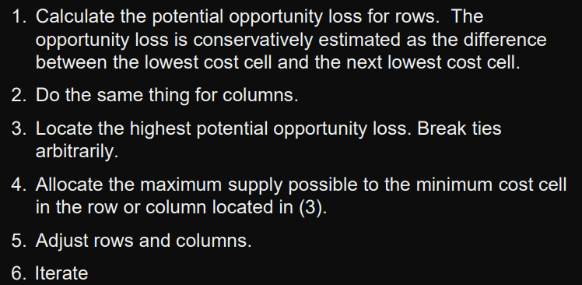 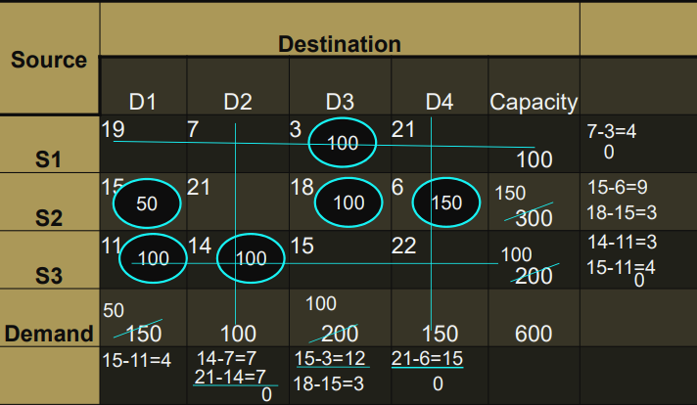 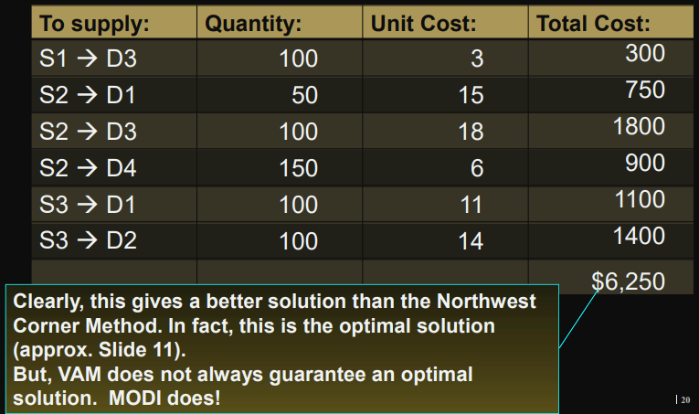

### MODI (The Closed-Loop Method)

Modified Distribution Method/ Modified Dantzig Iteration Algorithm

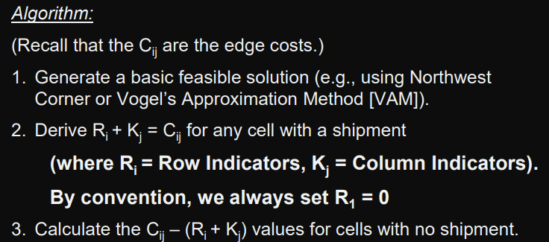 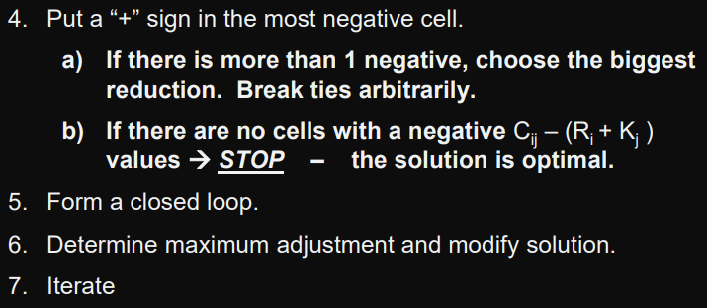

Start with NCM

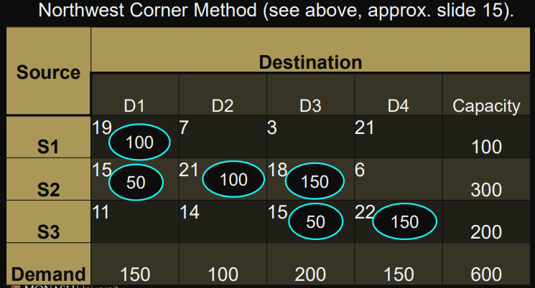 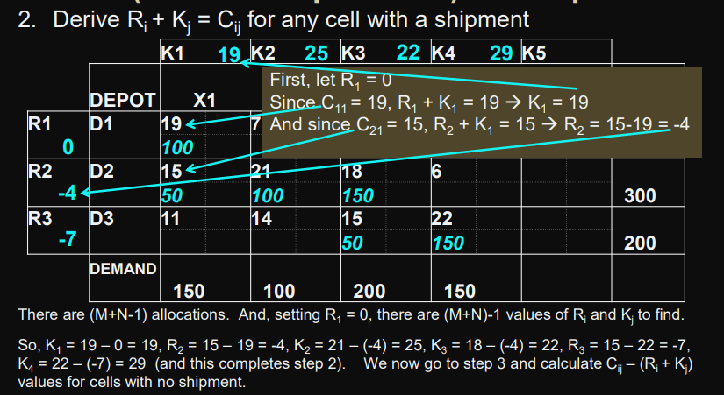 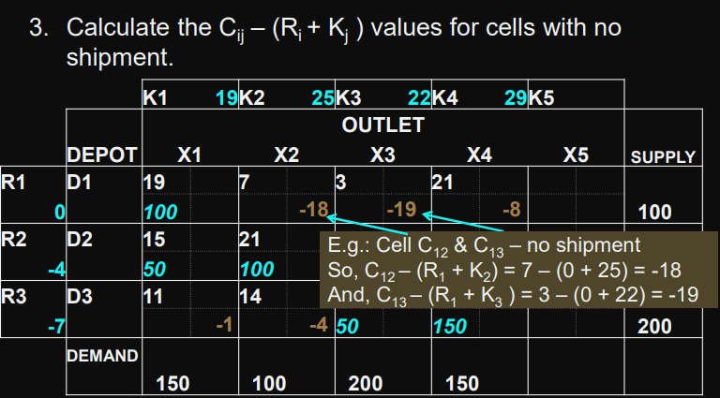 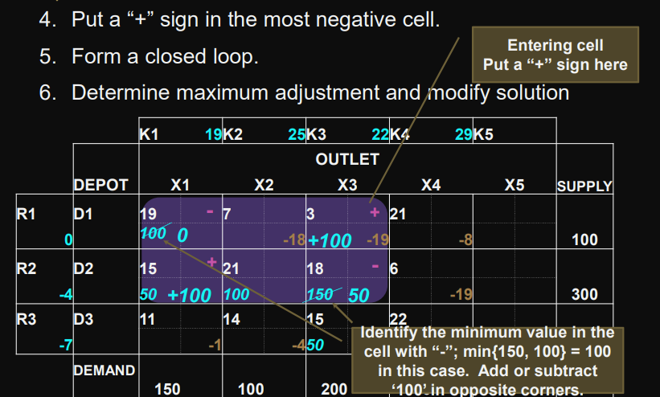 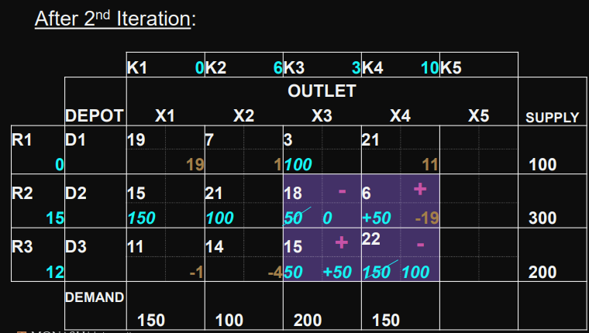 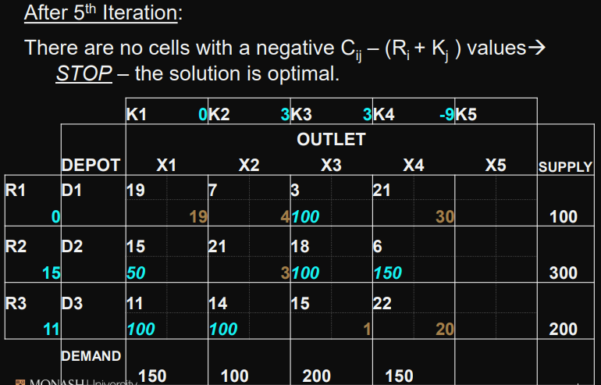 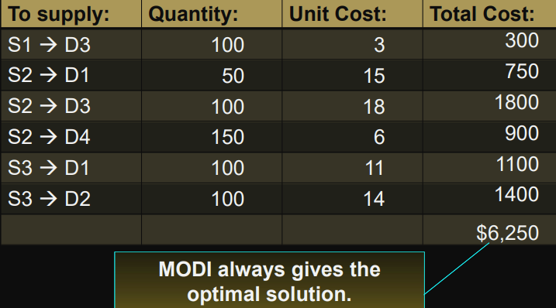

### Some issues to take note

* When supply does not equal demand
  + add a dummy column for demand to make up for the difference 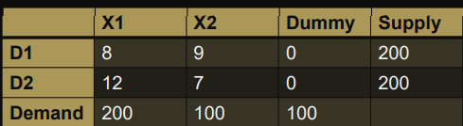
  + when demand > supply, add a dummy row for supply
  + the first step in doing any allocations is to check whether the demand and supply are equal
* When there’s a case of degeneracy
  + 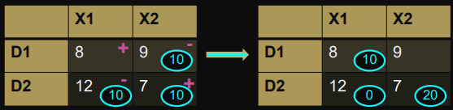
  + We now ended up having 2 allocations, thus breaking the (M + N – 1) rule.
  + we put a zero (0) in one of the cells.

# Assignment Problem

* minimize the total cost assignment of m workers to m jobs
* assumes all workers are assigned and each job is performed
* special case of a transportation problem in which all supplies and all demands are equal to 1; hence assignment problems may be solved as linear program

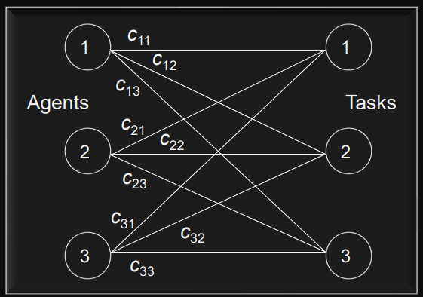

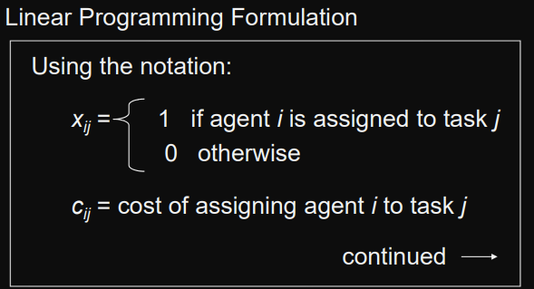 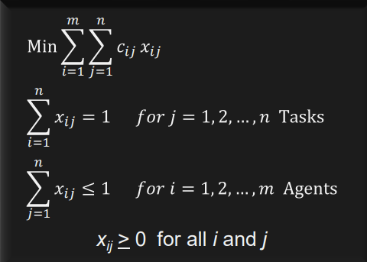

## Special Cases

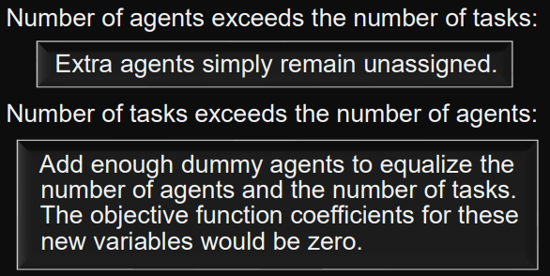 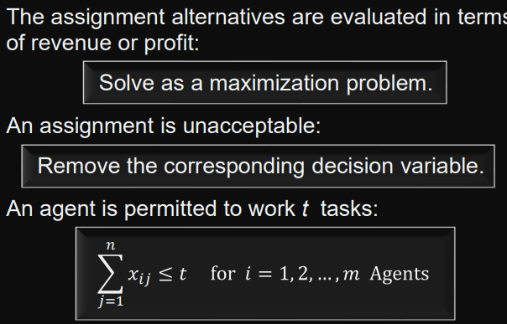

## Example

